WEEK 6 -HANDS ON EXERCISES:

EXERCISE 1:

1.ReactJS-HOL

CODE:

//app.jsx

function App() {

return (

<div>

<h1>welcome to the first session of React</h1>

</div>

);

}

export default App;

OUTPUT:

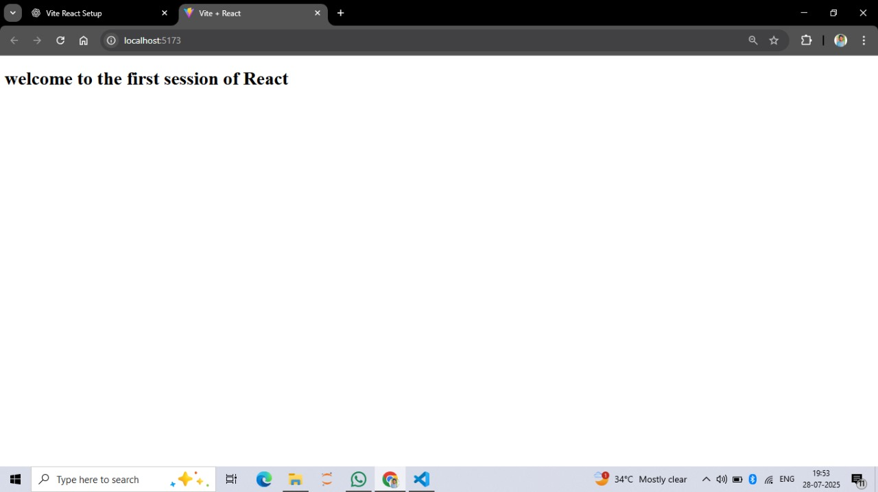

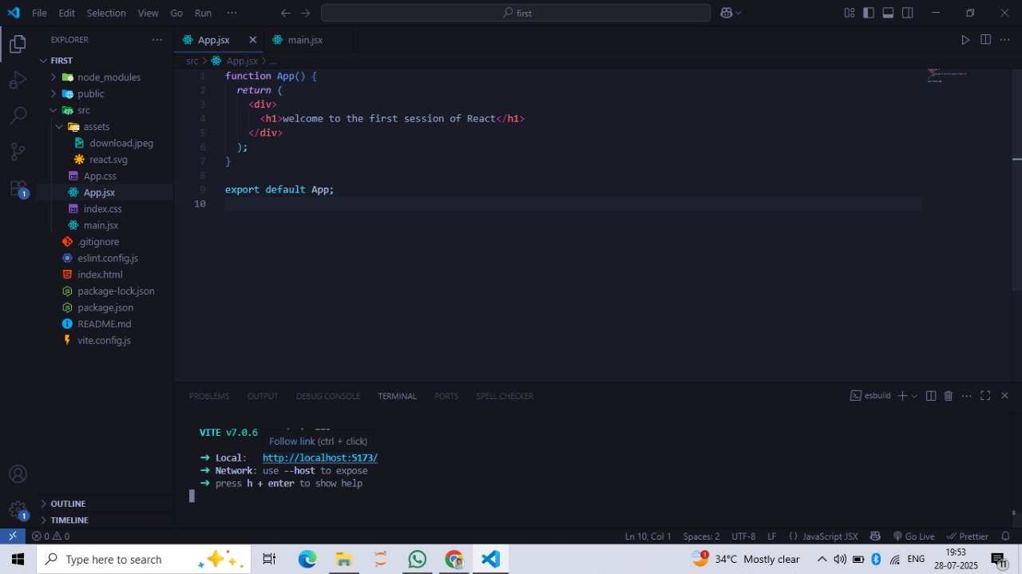

EXERCISES 2:

CODE:

//app.jsx

import Home from './Home';

import About from './About';

import Contact from './Contact';

function App() {

return (

<div>

<h1>Student Management Portal</h1>

<Home />

<About />

<Contact />

</div>

);

}

export default App;

//home .jsx

function Home() {

return <h2>Welcome to the Home page of Student Management Portal</h2>;

}

export default Home;

//about.jsx

function About() {

return <h2>Welcome to the About page of the Student Management Portal</h2>;

}

export default About;

//function Contact() {

return <h2>Welcome to the Contact page of the Student Management Portal</h2>;

}

export default Contact;

OUTPUT:

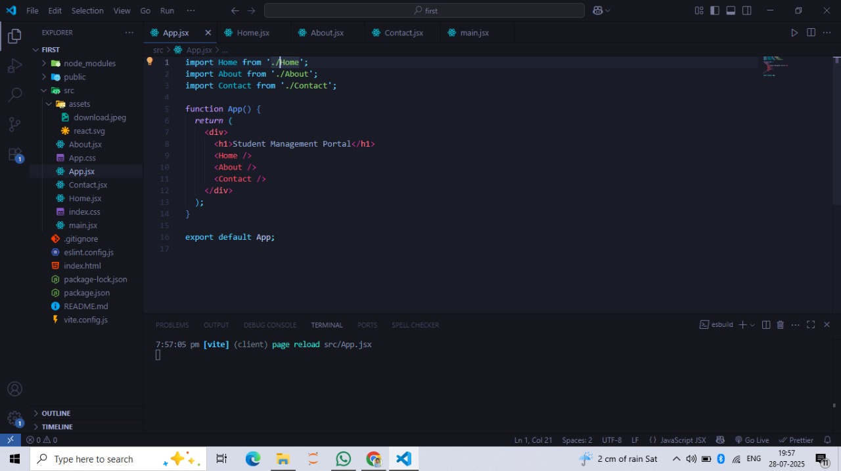

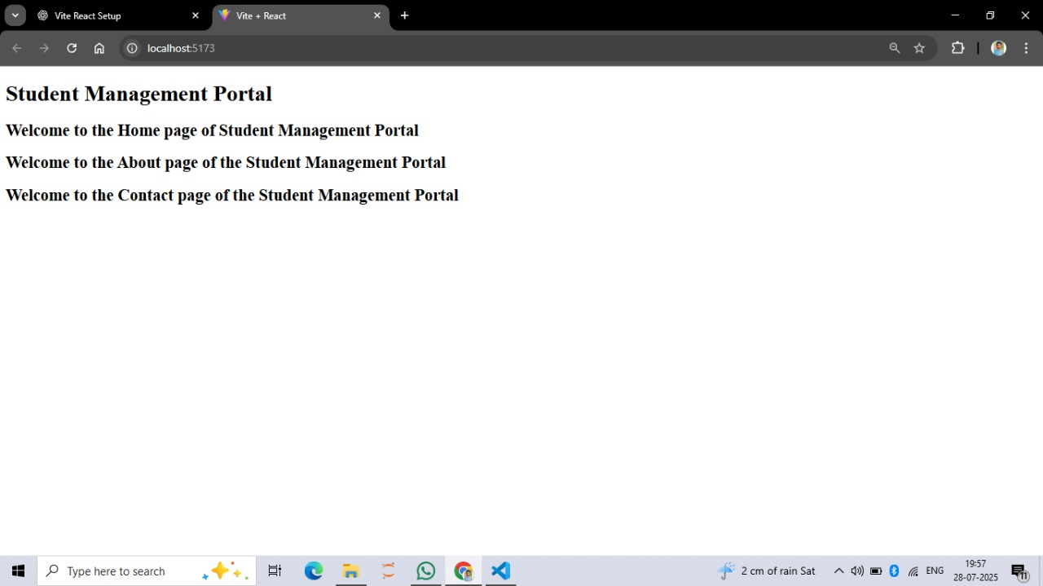

EXERCISE 3:

CODE

//app.jsx

import CalculateScore from './Components/CalculateScore';

function App() {

return (

<div>

<h1>Student Score Calculator</h1>

<CalculateScore />

</div>

);

}

export default App;

//CalculateScore.jsx

import '../Stylesheets/mystyle.css';

function CalculateScore() {

const name = "Lavanya";

const school = "Sunrise High School";

const total = 450;

const goal = 500;

const percentToDecimal = (decimal) => {

return (decimal \* 100).toFixed(2) + '%';

};

const calcScore = (total, goal) => {

return percentToDecimal(total / goal);

};

return (

<div className="formatstyle">

<h2 className="Name">Name: {name}</h2>

<h2 className="School">School: {school}</h2>

<h2 className="Total">Total Marks: {total}</h2>

<h2 className="Score">Average Score: {calcScore(total, goal)}</h2>

</div>

);

}

export default CalculateScore;

//mystyle.css

.Name {

font-weight: 300;

color: blue;

}

.School {

color: crimson;

}

.Total {

color: darkmagenta;

}

.Score {

color: forestgreen;

}

.formatstyle {

text-align: center;

font-size: large;

}

OUTPUT:

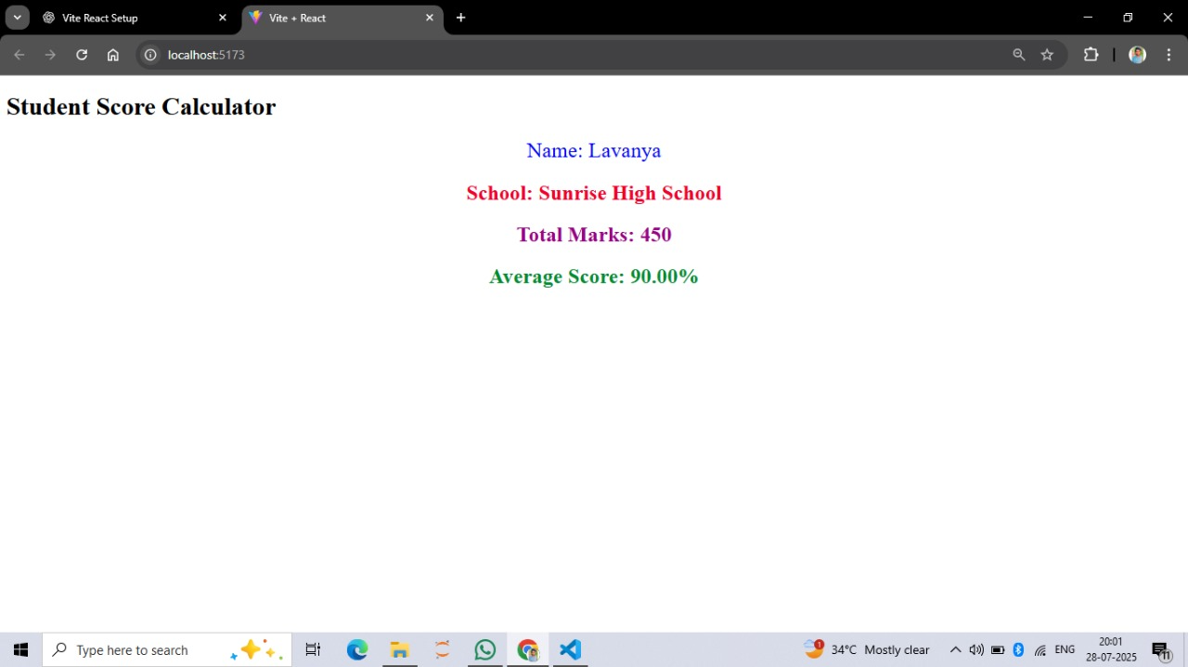

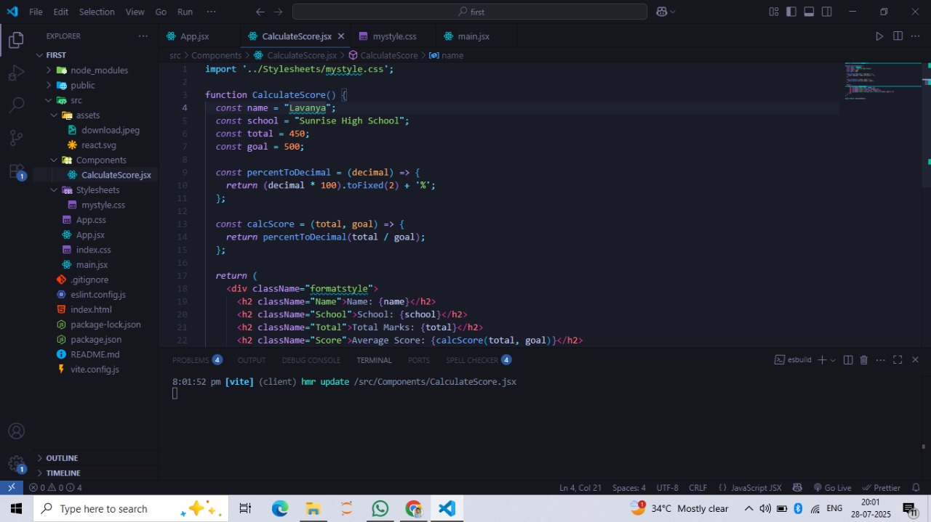

EXERCISE 4:

CODE:

//app.jsx

import React from 'react';

import Posts from './Posts';

function App() {

return (

<div>

<Posts />

</div>

);

}

export default App;

//post.jsx

import React from 'react';

class Post extends React.Component {

render() {

return (

<div style={{ border: '1px solid gray', margin: '10px', padding: '10px' }}>

<h3>{this.props.title}</h3>

<p>{this.props.body}</p>

</div>

);

}

}

export default Post;

//posts.jsx

import React from 'react';

import Post from './Post';

class Posts extends React.Component {

constructor(props) {

super(props);

this.state = {

posts: [],

hasError: false

};

}

componentDidMount() {

this.loadPosts();

}

loadPosts() {

fetch('https://jsonplaceholder.typicode.com/posts')

.then((response) => response.json())

.then((data) => this.setState({ posts: data }))

.catch((error) => {

console.error('Error fetching posts:', error);

this.setState({ hasError: true });

});

}

componentDidCatch(error, info) {

alert("An error occurred while rendering Posts component.");

console.error("Caught error:", error, info);

this.setState({ hasError: true });

}

render() {

if (this.state.hasError) {

return <h2>Something went wrong!</h2>;

}

return (

<div>

<h1>Blog Posts</h1>

{this.state.posts.slice(0, 10).map((post) => (

<Post key={post.id} title={post.title} body={post.body} />

))}

</div>

);

}

}

export default Posts;

OUTPUT:

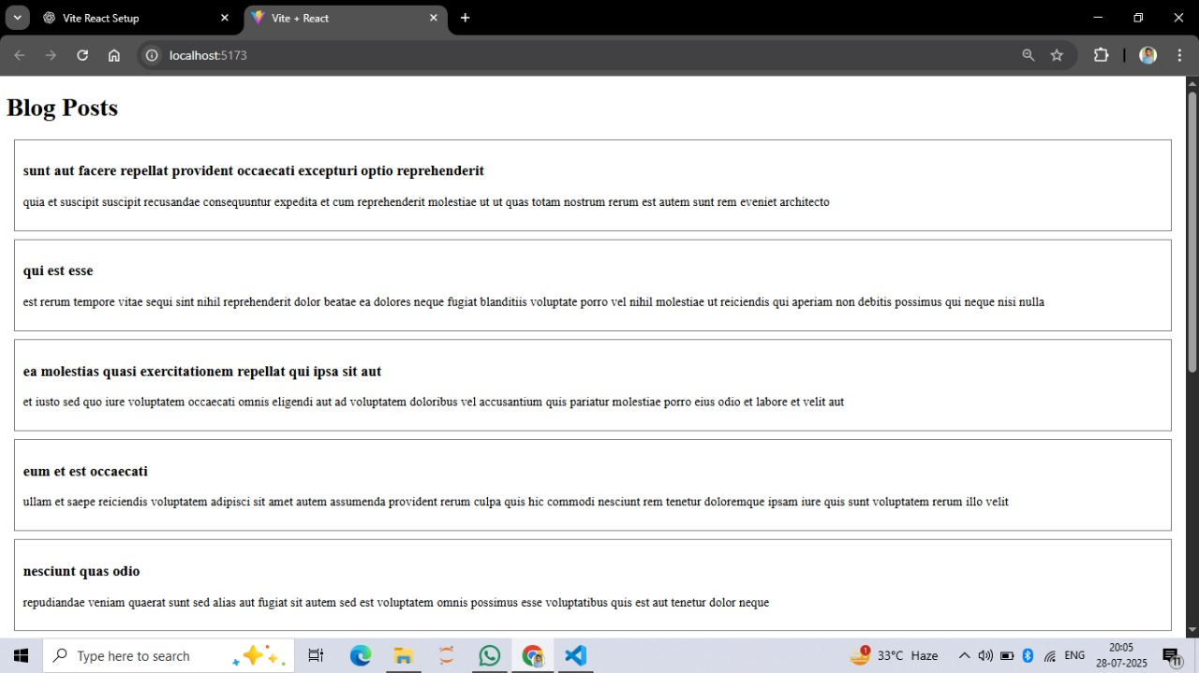

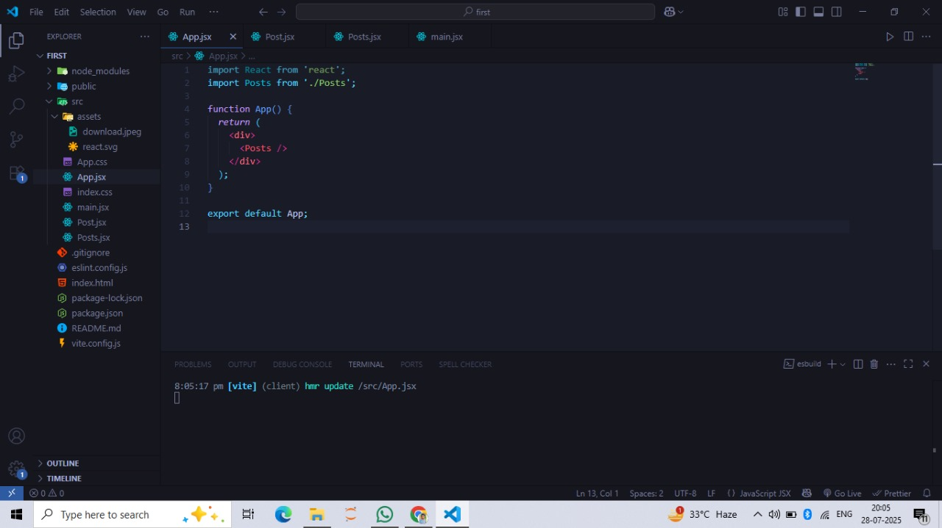

EXERCISE 5:

CODE:

//app.jsx

import CohortDetails from './CohortDetails';

function App() {

const cohorts = [

{

name: 'React Bootcamp',

startDate: '2025-07-01',

endDate: '2025-07-31',

status: 'ongoing'

},

{

name: 'NodeJS Crash Course',

startDate: '2025-06-01',

endDate: '2025-06-30',

status: 'completed'

}

];

return (

<div>

<h1>Cohort Dashboard</h1>

{cohorts.map((c, index) => (

<CohortDetails key={index} cohort={c} />

))}

</div>

);

}

export default App;

//CohortDetails.module.css

.box {

width: 300px;

display: inline-block;

margin: 10px;

padding: 10px 20px;

border: 1px solid black;

border-radius: 10px;

}

dt {

font-weight: 500;

}

//CohortDetails.jsx

import styles from './CohortDetails.module.css';

function CohortDetails({ cohort }) {

const headingStyle = {

color: cohort.status === 'ongoing' ? 'green' : 'blue'

};

return (

<div className={styles.box}>

<h3 style={headingStyle}>{cohort.name}</h3>

<dl>

<dt>Start Date:</dt>

<dd>{cohort.startDate}</dd>

<dt>End Date:</dt>

<dd>{cohort.endDate}</dd>

<dt>Status:</dt>

<dd>{cohort.status}</dd>

</dl>

</div>

);

}

export default CohortDetails;

OUTPUT